**DAILY ONLINE ACTIVITIES SUMMARY**

|  |  |  |  |  |  |  |  |  |
| --- | --- | --- | --- | --- | --- | --- | --- | --- |
| **Date:** | **28/05/2020** | | | | | **Name:** | **Katira Krishna J** | |
| **Sem & Sec** | **8th A** | | | | | **USN:** | **4AL16CS045** | |
| **Online Test Summary** | | | | | | | | |
| **Subject** | | **SMS** | | | | | | |
| **Max. Marks** | | **60** | | **Score** | | | **57** | |
| **Certification Course Summary** | | | | | | | | |
| **Course** | **Machine learning with python** | | | | | | | |
| **Certificate Provider** | | | **Cognitiveclass.ai** | | **Duration** | | | **12 Hours** |
| **Coding Challenges** | | | | | | | | |
| **Problem Statement:**  Pink Floyd and Happiness | | | | | | | | |
| **Status: Completed** | | | | | | | | |
| **Uploaded the report in Github** | | | | | **yes** | | | |
| **If yes Repository name** | | | | | **Krishna_Katira** | | | |
| **Uploaded the report in slack** | | | | | **yes** | | | |

Online Test Details:

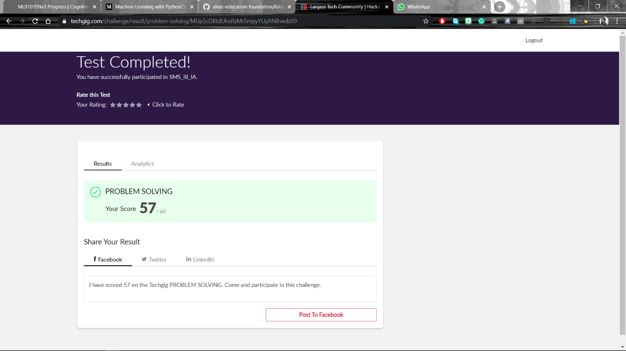

Certification Course Details:

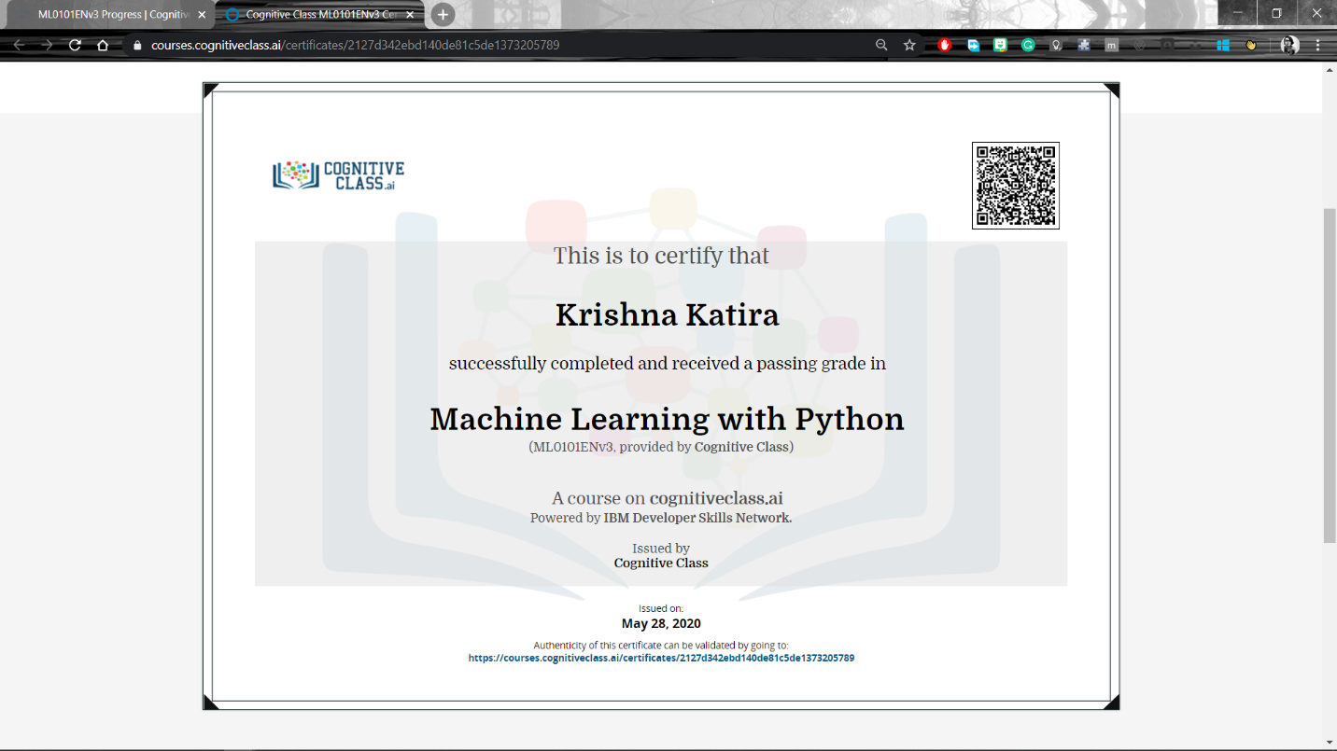

Coding Challenges Details:

**program1**

l=list()

s=list()

n=int(input())

for i in range(0,n):

m=int(input())

l.append(m)

s.append(i+1)

l.sort()

if l==s:

print("happy")

else:

print("sad")